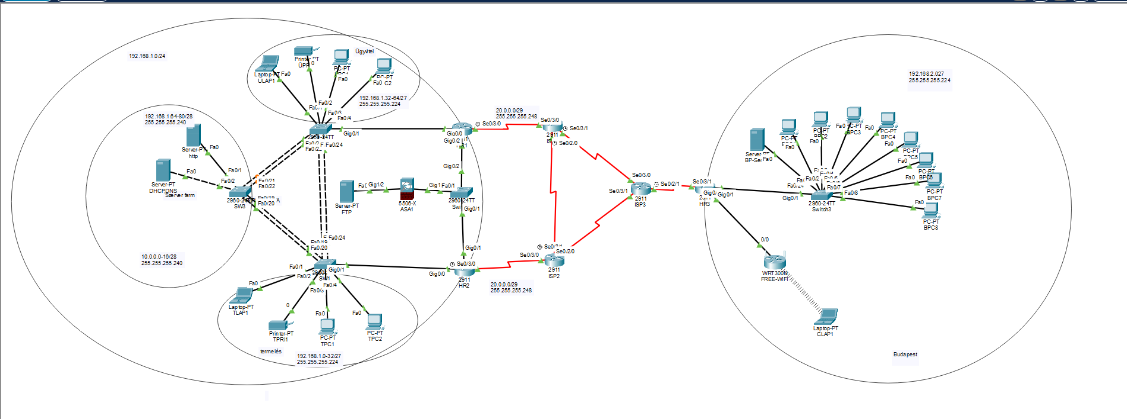

NYÍREGYHÁZI TELEPHELY
HÁLÓZATI TERV
NÉV | VLAN-ID | HÁLÓZAT CÍM | MASZK
TERMELÉS | 10 | 192.168.1.0 | 255.255.255.224
SZERVERFARM | 30 | 192.168.1.64 | 255.255.255.240
ÜGYVITEL | 20 | 192.168.1.32 | 255.255.255.224
BELSŐHÁLÓ | 77 | 192.168.1.80 | 255.255.255.240
DMZ | ----- | 192.168.2.0 | 255.255.255.248
OUTSIDE | ----- | 19.0.0.0 | 255.255.255.0
IPV4-ES CÍMTÁBLA
ESZKŐZ NÉV | INTERFACE | IP CÍM | MASZK | ALAPÉRTELMEZETT ÁTJÁRÓ
HR1 | G0/0.10 | 192.168.1.3/27 | 255.255.255.224
 | G0/0.20 | 192.168.1.35/27 | 255.255.255.224
 | G0/0.30 | 192.168.1.65/28 | 255.255.255.240
 | G0/0.77 | 192.168.1.81/28 | 255.255.255.240
HR2 | G0/0.10 | 192.168.1.2/27 | 255.255.255.224
 | G0/0.20 | 192.168.1.34/27 | 255.255.255.224
 | G0/0.30 | 192.168.1.66/28 | 255.255.255.240
 | G0/0.77 | 192.168.1.82/28 | 255.255.255.240
SW1 | VALN77 | 192.168.1.83/28 | 255.255.255.240 | 192.168.1.81
SW2 | VALN77 | 192.168.1.84/28 | 255.255.255.240 | 192.168.1.81
SW3 | VALN77 | 192.168.1.85/28 | 255.255.255.240 | 192.168.1.81
TPRI1 | VLAN10 | 192.168.1.5/27 | 255.255.255.224 | 192.168.1.1
TLAP1 | VLAN10 | DHCP
TPC1 | VLAN10 | DHCP
TPC2 | VLAN10 | DHCP
ÜPRI1 | VLAN20 | 192.168.1.36/27 | 255.255.255.224 | 192.168.1.33
ÜLAP1 | VLAN20 | DHCP
ÜPC1 | VLAN20 | DHCP
ÜPC2 | VLAN20 | DHCP
DHCP | VLAN30 | 192.168.1.67/28 | 255.255.255.240 | 192.168.1.65
TFTP | VLAN30 | 192.168.1.69 | 255.255.255.240 | 192.168.1.65
HTTP, DNS | DMZ | 10.0.0.3 | 255.255.255.240 | 10.0.0.1
ASA1 | G1/1 | 19.0.0.0 | 255.255.255.0
 | G1/2 | 10.0.0.1/29 | 255.255.255.248
FTP | DMZ | 10.0.0.2/29 | 255.255.255.248 | 10.0.0.1

ISP
NÉV |  | HÁLÓZAT CÍM |  | MASZK
HR1 ISP1 |  | 20.0.0.0 |  | 255.255.255.252
HR2ISP2 |  | 21.0.0.0 |  | 255.255.255.252
ISP1ISP2 |  | 22.0.0.0 |  | 255.255.255.252
ISP1ISP3 |  | 23.0.0.0 |  | 255.255.255.252
ISP2ISP3 |  | 24.0.0.0 |  | 255.255.255.252
ISP3HR3 |  | 25.0.0.0 |  | 255.255.255.252
ISP
HR1ISP1 | SE0/3/0 |  | 20.0.0.1/30 |  | 255.255.255.252
ISP1HR1 | SE0/3/0 |  | 20.0.0.2/30 |  | 255.255.255.252
HR2ISP2 | SE0/3/0 |  | 21.0.0.1/30 |  | 255.255.255.252
ISP2HR2 | SE0/3/0 |  | 21.0.0.2/30 |  | 255.255.255.252
ISP1ISP2 | SE0/2/0 |  | 22.0.0.1/30 |  | 255.255.255.252
ISP2ISP1 | SE0/2/0 |  | 22.0.0.2/30 |  | 255.255.255.252
ISP1ISP3 | SE0/3/1 |  | 23.0.0.1/30 |  | 255.255.255.252
ISP3ISP1 | SE0/3/0 |  | 23.0.0.2/30 |  | 255.255.255.252
ISP2ISP3 | SE0/3/1 |  | 24.0.0.1/30 |  | 255.255.255.252
ISP3ISP2 | SE0/3/1 |  | 24.0.0.2/30 |  | 255.255.255.252
ISP3HR3 | SE0/2/1 |  | 25.0.0.1/30 |  | 255.255.255.252
HR3ISP3 | SE0/3/1 |  | 25.0.0.2/30 |  | 255.255.255.252
HR1HR3 | tunnel1 |  | 192.168.100.1 |  | 255.255.255.252
HR3HR1 | tunnel1 |  | 192.168.100.2 |  | 255.255.255.252
HR3HR2 | runnel2 |  | 192.168.101.2 |  | 255.255.255.252
HR2HR3 | tunnel2 |  | 192.168.101.1 |  | 255.255.255.252

BUDAPEST
NÉV | HÁLÓZAT CÍM | MASZK
IRODA | 192.168.2.0 | 255.255.255.224
HR3VÁRÓ | 192.168.3.0 | 255.255.255.252
VÁRÓ | 192.168.50.0 | 255.255.255.128

BUDAPEST
HR3 | G0/0 | 192.168.2.0/27 | 255.255.255.224
 | G0/1 | 192.168.3.0/24 | 255.255.255.0
BPC1-8 | Fa0/1-8 | DHCP
BP-SERVER | Fa0/24 | 192.168.2.3 | 255.255.255.0 | 192.168.2.1
FREE-WIFI |  | 192.168.4.0 | 255.255.255.0

Helyszín | Eszköz | Interfész / VLAN | IPv6 cím | Prefix | Gateway
Nyíregyháza | HR1 | G0/0.10 | 2001:db8:1:10::1 | /64
 |  | G0/0.20 | 2001:db8:1:20::1 | /64
 |  | G0/0.30 | 2001:db8:1:30::1 | /64
 |  | G0/0.77 | 2001:db8:1:77::1 | /64
 |  | SER0/3/0 | 2001:DB8:FF:1::1 | /64 | -
Nyíregyháza | HR2 | G0/0.10 | 2001:db8:1:10::2 | /64
 |  | G0/0.20 | 2001:db8:1:20::2 | /64
 |  | G0/0.30 | 2001:db8:1:30::2 | /64
 |  | G0/0.77 | 2001:db8:1:77::2 | /64
 |  | SER0/3/0 | 2001:DB8:FF:2::1 | /64 | -
Nyíregyháza | SW1 | VLAN77 | 2001:db8:1:77::11 | /64
Nyíregyháza | SW2 | VLAN77 | 2001:db8:1:77::12 | /64
Nyíregyháza | SW3 | VLAN77 | 2001:db8:1:77::13 | /64
Nyíregyháza | TPRI1 | VLAN10 | 2001:db8:1:10::10 | /64 | 2001:db8:1:10::1
Nyíregyháza | TLAP1 | VLAN10 | DHCPv6 | /64 | 2001:db8:1:10::1
Nyíregyháza | TPC1 | VLAN10 | DHCPv6 | /64 | 2001:db8:1:10::1
Nyíregyháza | TPC2 | VLAN10 | DHCPv6 | /64 | 2001:db8:1:10::1
Nyíregyháza | ÜPRI1 | VLAN20 | 2001:db8:1:20::10 | /64 | 2001:db8:1:20::1
Nyíregyháza | ÜLAP1 | VLAN20 | DHCPv6 | /64 | 2001:db8:1:20::1
Nyíregyháza | ÜPC1 | VLAN20 | DHCPv6 | /64 | 2001:db8:1:20::1
Nyíregyháza | ÜPC2 | VLAN20 | DHCPv6 | /64 | 2001:db8:1:20::1
Nyíregyháza | DHCP/DNS | VLAN30 | 2001:db8:1:30::10 | /64 | 2001:db8:1:30::1
Nyíregyháza | HTTPS | VLAN30 | 2001:db8:1:30::20 | /64 | 2001:db8:1:30::1
Nyíregyháza | ASA1 | G1/1 (Inside) | 2001:db8:1:77::20 | /64
Nyíregyháza | ASA1 | G1/2 (DMZ) | 2001:db8:1:100::1 | /64
Nyíregyháza | FTP Server | DMZ | 2001:db8:1:100::10 | /64 | 2001:db8:1:100::1
WAN | ISP1 | SER 0/3/0 | 2001:DB8:FF:1::2 | /64 | -
WAN | ISP1 | SER0/2/0 | 2001:DB8:FF:3::1 | /64 | -
WAN | ISP1 | SER0/3/1 | 2001:DB8:FF:4::1 | /64 | -
WAN | ISP2 | SER0/2/0 | 2001:DB8:FF:3::2 | /64 | -
WAN | ISP2 | SER0/3/0 | 2001:DB8:FF:2::2 | /64 | -
WAN | ISP2 | SER0/3/1 | 2001:DB8:FF:5::1 | /64 | -
WAN | ISP3 | SER0/2/1 | 2001:DB8:FF:6::2 | /64 | -
WAN | ISP3 | SER0/3/0 | 2001:DB8:FF:4::2 | /64 | -
WAN | ISP3 | SER0/3/1 | 2001:DB8:FF:5::2 | /64 | -
Budapest | HR3 | G0/0 | 2001:db8:2:10::1 | /64
Budapest | HR3 | G0/1 | 2001:db8:2:20::1 | /64
Budapest | HR3 | SER0/3/1 | 2001:DB8:FF:6::1 | /64 | -
Budapest | BPC1-8 | LAN | DHCPv6 | /64 | 2001:db8:2:10::1
Budapest | BP-SERVER | LAN | 2001:db8:2:10::10 | /64 | 2001:db8:2:10::1

PROTOKOLOK:

szerverek:
mit csinálnak, beállításai.
magyarázat a szerver konfigról

ACL ASA

programozás :
python-ban
routeren futtatható program napi log jelentést csináljon.

